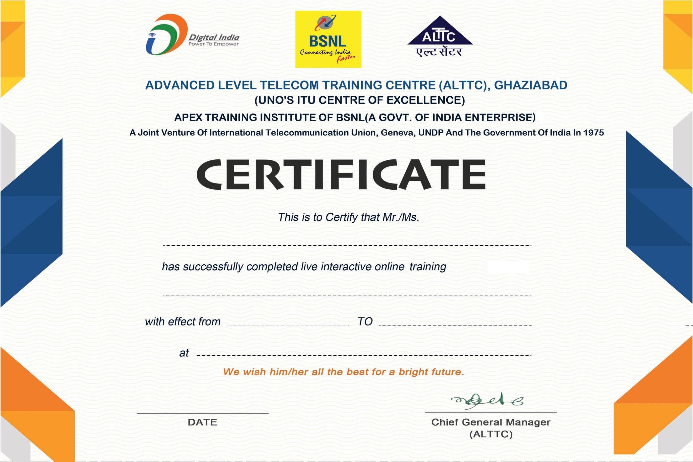 RHYTMNB1743-2020-7454123

ALURU PRAVEEN

ONLINE INTERNSHIP TRAINING WITH PROJECT- 1 YEAR

20/06/2019 08/11/2019

RTTC HYDERABAD

08/11/2019